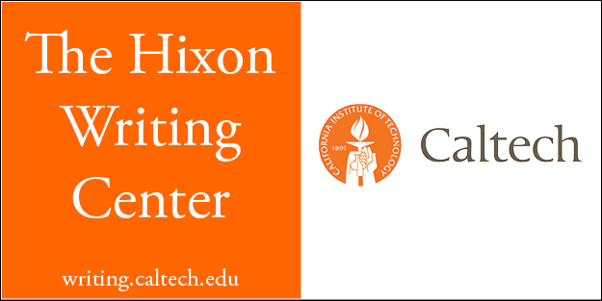

Sample Collaboration Policy
Both novice and professional academic writers commonly work with others to improve their written work. There are several roles that others might serve for academic writers. Co-authors are the other people who help an author create a work by generating original language, developing key ideas, gathering data, or refining methods. As a result, all co-authors' names appear on the final text of the work. Reviewers read and make suggestions toward the improvement of a piece of writing, usually in the form of marginal comments, endnotes, or conversations that explain their impressions of the strengths and limits of the draft. The author is then left to figure out how to make revisions in response to that feedback. Editors differ from reviewers that they offer much more directive advice about what must be done to improve a text, and they often will generate specific language that is then incorporated into the text.
For our class your collaboration with others must be limited to reviewing. You can and should seek out trusted reviewers for your writing, including peers inside the class, friends outside the class, and the tutors in the Hixon Writing Center. Listen critically to their thoughts about your work-in-progress. Decide how useful their feedback seems, and figure out how you will translate their comments into the improvement of your work. You cannot, however, ask or allow anyone to co-author or edit your essay; no one but you can generate new language or make decisions about how to reorganize or otherwise change the essay.
You are not allowed to collaborate with professional co-authors, reviewers, or editors outside of Caltech who are remunerated for their work on your writing.
If you find yourself in a gray area related to collaboration, bring your concerns to the professor before submitting the essay, when we can work through them together. If overcollaboration is discovered after the essay is submitted, it will be referred to the Board of Control.

